

DLD Lab Quiz#3

By:  
  
Name:  
Abdul-Rehman  
Roll.no:  
19l-1135  
Section:   
CS-D

**Q**

**(a)**

**State table:**

|  |  |  |  |  |  |  |  |  |  |  |  |
| --- | --- | --- | --- | --- | --- | --- | --- | --- | --- | --- | --- |
| Q2 | Q1 | Q0 | Q2+ | Q1+ | Q0+ | J0 | K0 | J1 | K1 | J2 | K2 |
| 0 | 0 | 0 | 1 | 1 | 1 | 1 | x | 1 | x | 1 | x |
| 0 | 0 | 1 | 0 | 0 | 0 | x | 1 | 0 | x | 0 | x |
| 0 | 1 | 0 | 0 | 0 | 1 | 1 | x | x | 1 | 0 | x |
| 0 | 1 | 1 | 0 | 1 | 0 | x | 1 | x | 0 | 0 | x |
| 1 | 0 | 0 | 0 | 1 | 1 | 1 | x | 1 | x | x | 1 |
| 1 | 0 | 1 | 1 | 0 | 0 | x | 1 | 0 | x | x | 0 |
| 1 | 1 | 0 | 1 | 0 | 1 | 1 | x | x | 1 | x | 0 |
| 1 | 1 | 1 | 1 | 1 | 0 | x | 1 | x | 0 | x | 0 |

**(b)**

**Input Equations:**

|  |
| --- |
| **J0=1** |
| **k0=1** |
| **J1=Q0'** |
| **K1=Q0'** |
| **J2=Q1'Q0'** |
| **K2=Q1'Q0'** |

**(c)**

**Circuit Diagram:**

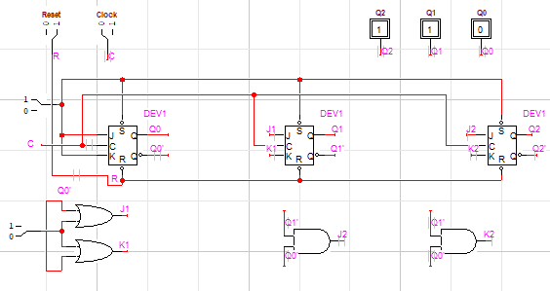

**THANK YOU**

